HOMEWORK WEEK3 – DATA WAREHOUSE

Question 1. What is count of records for the 2024 Yellow Taxi Data? (1 point)
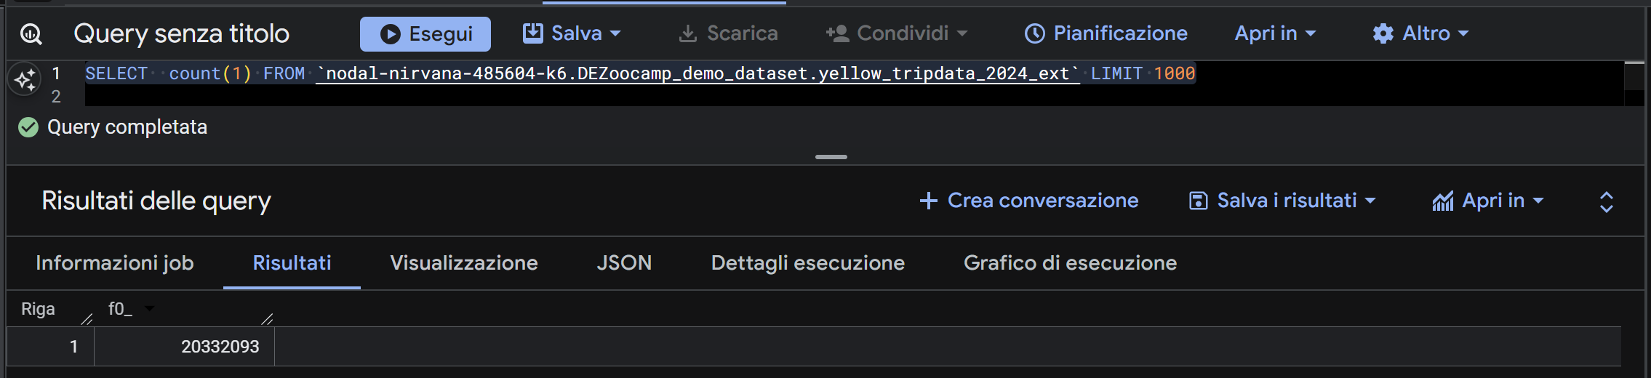

Question 2. What is the estimated amount of data that will be read when this query is executed on the External Table and the Table? (1 point)
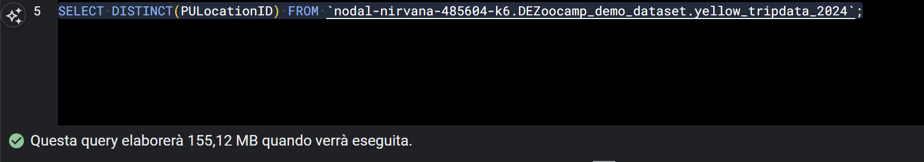

Question 4. How many records have a fare_amount of 0? (1 point)
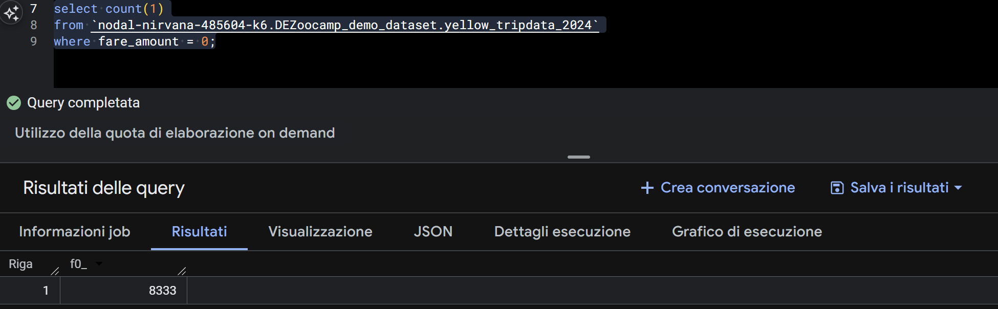

Question 5. What is the best strategy to make an optimized table in Big Query if your query will always filter based on tpep_dropoff_datetime and order the results by VendorID (Create a new table with this strategy) (1 point)

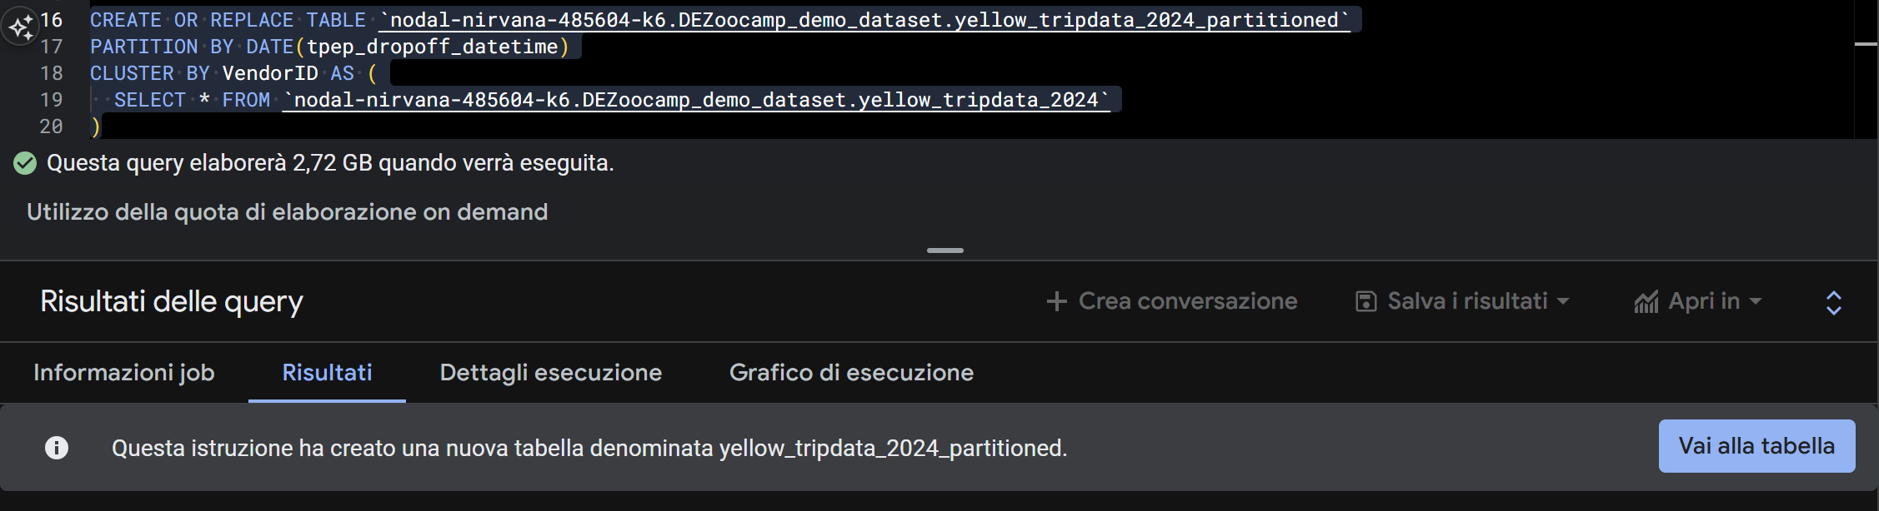

Question 6. Write a query to retrieve the distinct VendorIDs between tpep_dropoff_datetime 2024-03-01 and 2024-03-15 (inclusive). Use the materialized table you created earlier in your from clause and note the estimated bytes. Now change the table in the from clause to the partitioned table you created for question 5 and note the estimated bytes processed. What are these values? (1 point)
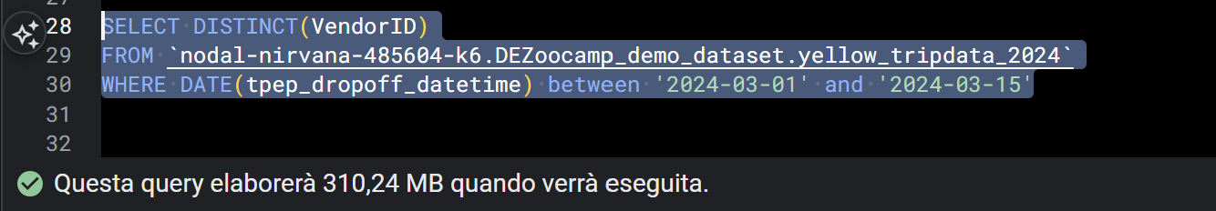
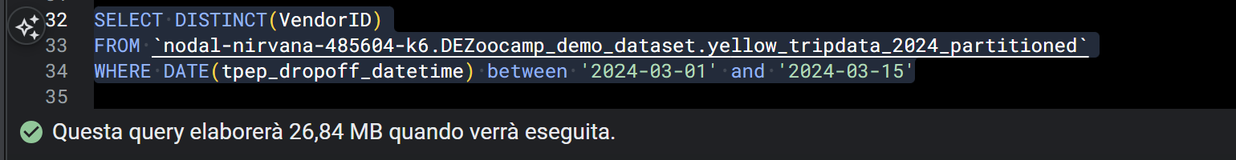

Question 9. Write a `SELECT count(*)` query FROM the materialized table you created. How many bytes does it estimate will be read? Why? (not graded)
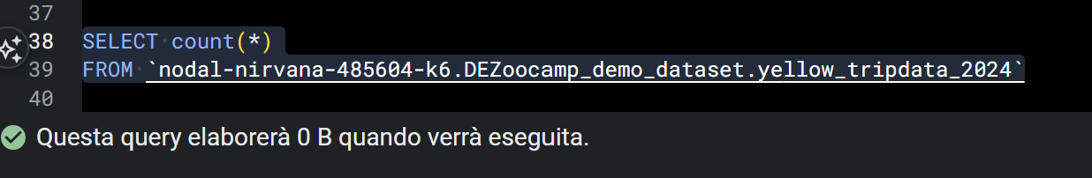
Because BigQuery stores the total number of rows (row count) in the native (materialised) table metadata. When you run a SELECT count(*) without filters on a table of this type, BigQuery does not need to scan any physical columns or rows; it simply reads that single value from the metadata, which does not involve any data processing costs.

